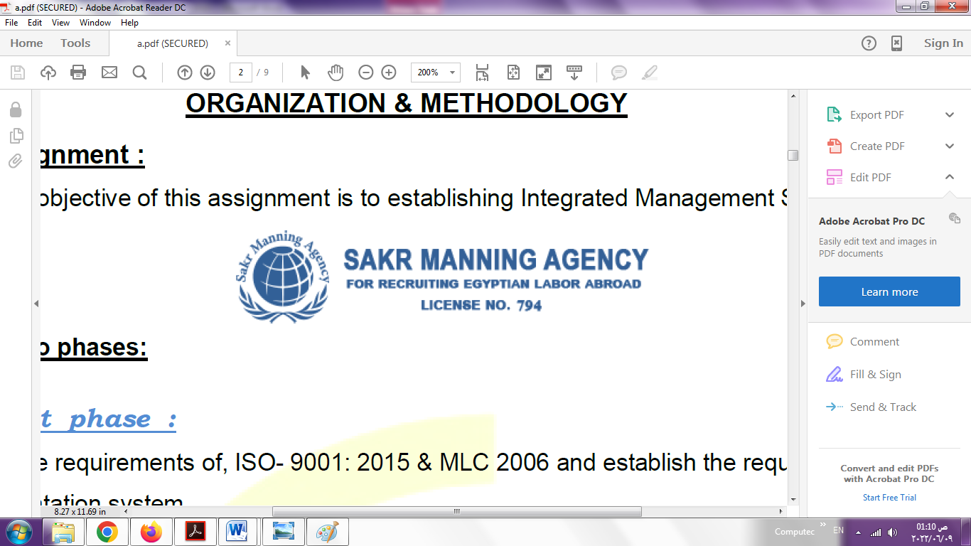 | SAKR MANNING AGENCY  FOR RECRUITING EGYPTIAN LABOR ABROAD | Issue Date | 15.05.2022
 |  | Revision Date | 19.07.2022
 | Crewing Management Manual  Seafarer Employment Application | Revision | 1.1
 |  | Page | 3

Application For Position as | Mechanic
Register Code.
Other Position (If Any) | oiler
Register Date
Last up Date Data
Expected Salary

1. PERSONAL DETAILS
Full Name |  | Mohamed Bassam Bassam Mohamed Hashish
Date Of Birth |  | 12/01/1991 |  |  |  |  |  |  | Place Of Birth |  |  |  |  |  |  |  | Alexandria
Nationality |  | Egyptian |  |  |  |  |  |  | Marital Status |  |  |  |  |  |  |  | Single ☐single |  |  |  |  |  |  |  | Married ☐
Height (Cm) |  | 175 |  |  |  |  |  |  | Overall Size |  |  |  |  |  |  |  | Large |  |  |  |  | Shirt Size |  |  |  |  |  | 37 38
Weight (Kg) |  | 70 |  |  |  |  |  |  | Trouser Size |  |  |  |  |  |  |  | 36 |  |  |  |  | Shoes Size |  |  |  |  |  | 43
2. EDUCATION
College / School |  | Diploma in Industries, Department of Marine Engines
Marline Test |  | Issued Date |  |  |  |  | Result % |  |  |  | Issued By (Authority) |  |  |  |  |  |  |  |  |  | Issued At
English Language |  | Fluent ☐ |  |  |  |  |  | Good ☐good |  |  |  |  | Average ☐ |  |  |  |  |  |  |  | Poor ☐
……… Language  ( good ) |  | Fluent ☐ |  |  |  |  |  | Good ☐good |  |  |  |  | Average ☐ |  |  |  |  |  |  |  | Poor ☐
3. CONTACT DETAILS
Home Address / City |  |  | 53st Ali heba Victoria Gamal Abd elnasar Alexandria
E-Mail |  |  | Mbassam990@gmail.com |  |  |  |  |  |  | Mobile / Tel |  |  |  |  |  | +201016749923 |  |  |  |  |  |  | +2033595220

4. TRAVEL DOCUMENTS
Type |  | Document No. |  |  |  | ISS. Date |  |  | Exp. Date |  |  |  |  | ISS. By (Authority) |  |  |  |  |  |  |  |  |  | Place of Issue
Passport |  | A29970216 |  |  |  | 09/03/2022 |  |  | 08/03/2029 |  |  |  |  | Egyptian Authority |  |  |  |  |  |  |  |  |  | Alexandria
Seaman Book |  | S00025128 |  |  |  | 11/09/2022 |  |  | 03/09/2027 |  |  |  |  | EAMS |  |  |  |  |  |  |  |  |  | Alex.
Other Seaman Book

5. PROFESSIONAL QUALIFICATION / CERTIFICATE OF COMPETENCY
Certificate Name |  |  |  |  | Number | Issue Date |  |  |  |  |  | Expiry Date |  |  |  |  |  | Issued By |  |  |  |  |  |  |  |  | Issued At
COC |  |  |  |  |  |  |  |  |  |  |  |  |  |  |  |  |  | EAMS |  |  |  |  |  |  |  |  | Alex.
GOC |  |  |  |  |  |  |  |  |  |  |  |  |  |  |  |  |  | NTRA |  |  |  |  |  |  |  |  | Cairo
D.P. INDUCTION
D.P. ADVANCED
D.P. OPERATOR (UNLIMITED)
6. NEXT OF KIN
Full Name | Bassam Bassam Mohamed Hashish |  |  |  |  |  |  |  |  |  |  |  |  |  | Relationship |  |  |  |  | Father
Address | 53st Ali heba Victoria Gamal Abd alnasar Alexandria
Tel. No. | +2033595220 |  |  |  |  |  |  |  |  | Mobile |  |  | +201284567500
7. HEALTH CERTIFICATES & VACCINATIONS
Flag State |  |  |  | Number |  |  | Issue Date |  |  |  |  | Expiry Date |  |  |  |  |  |  | Issued By |  |  |  |  |  |  | Issued At
International Medical |  |  |  |  |  |  | 24/04/2018 |  |  |  |  |  |  |  |  |  |  |  | EAMS |  |  |  |  |  |  | Alex.
Yellow Fever |  |  |  |  |  |  |  |  |  |  |  |  |  |  |  |  |  |  | Ministry of Health
Cholera |  |  |  |  |  |  |  |  |  |  |  |  |  |  |  |  |  |  | Ministry of Health
Covid-19 |  |  |  | Vaccination Name |  |  | First Dose |  |  |  |  | Second Dose |  |  |  |  |  |  | (Other Does or Remarks)
 |  |  |  |  |  |  |  |  |  |  |  | Second Dose

8. MARINE COURSES
Course Name |  | Number | Issue Date | Expiry Date | Issued By / At
Personal Survival Techniques |  | H0001321 | 10/08/2022 | 06/08/2027 | Studies Institute Alexandria
Proficiency In Personal Survival Techniques
Fire Prevention and Fire Fighting |  | H0001423 | 11/08/2022 | 08/08/2027 | Studies Institute Alexandria
Advanced Fire Prevention and Fire Fighting
Elementary First Aid |  | H0001336 | 10/08/2022 | 06/08/2027 | Studies Institute Alexandria
Medical Care Studies
Personal Safety and Social Responsibilities |  | H0001495 | 15/08/2022 | 08/08/2027 | Studies Institute Alexandria
Proficiency Of Security Awareness Training Seafarers |  | NR5345 | 04/05/2019 | 01/05/2024 | Studies Institute Alexandria
Proficiency as a ship Security officer ( PSSO )
Proficiency In Survival Craft & Rescue Boats |  | NR5619 | 12/05/2019 | 08/05/2024 | Studies Institute Alexandria
G.M.D.S.S
Communications
Advanced Communications
ECDIS Advanced Simulator (Management Level)
ECDIS Simulator (Operation Level)
Prevention and Combating of Marine Pollution
Radar & ARPA Simulator and Search &rescue
ARPA Simulator and Search
Marine Radar and automatic Radar Plotting
Bridge resource Management (B.R.M)
Engine resource Management (E.R.M)
Navigational Watch keeping
Proficiency for Rating forming part of Navigational watch (II/4) |  |  |  |  | EAMS / Alex.
High voltage training – operation of ship (1000 Volt and More)
Passenger Safety Cargo Safety and Hull integrity
Crowd Management Training
Crisis Management and Human Behavior Training
Safety training for Personal Prov. Direct Passengers
Practical Ability to Prepare Meals and (MLC 2006)
Personal Hygiene and Envir. Protection (MLC 2006)
Safety and Health in the Provision Meals (MLC 2006)
Food Storage and inventory Control (MLC 2006)
Ships Cook Certificate (MLC 2006) |  |  |  |  | EAMS / Alex.
Abel Seafarer Deck
Proficiency for Abel Seafarer Deck ( II/5 ) |  |  |  |  | EAMS / Alex.
Engineering Watch keeping |  |  |  |  | EAMS / Alex.
Proficiency for Rating forming part of a watch in engine room
Abel Seafarer Engine |  | 200045694 | 27/02/2018 |  | THE ARAB ACADEMY ALEXANDRIA 60
Proficiency for Abel Seafarer Engine ( III/5 ) |  | 00316 | 03/10/2022 |  | EAMS / Alex.
Electro Technical Rating
Proficiency for Electro Technical rating ( III/7 ) |  |  |  |  | EAMS / Alex.

COMPLETE SEA – SERVICE DETAILS

Name: |  |  |  |  |  |  |  | Rank: |  |  |  |  |  |  |  | Register Code:
Company Name |  |  | Rank |  | Vessel Name |  |  |  | Signed On |  |  | Signed Off |  |  |  | Period |  |  | Vessel Type |  | D.W.T. |  |  |  |  | Engine Type |  |  | BH | KW
INSPECTA 7 |  |  | Mechanic |  | INSPECTA 7 |  |  |  | 27/06/2016 |  |  | 05/11/2019 |  |  |  | 16 MONTH |  |  | Supply boat |  |  |  |  |  |  | wartsila |  |  | 5200 | 3900
ALLIANZ MIDDLE EAST |  |  | Mechanic |  | SWISSCO SUPPLIER |  |  |  | 07/11/2019 |  |  | 09/12/2019 |  |  |  | 1MONTH and 2days |  |  | Supply boat |  |  |  |  |  |  | Caterpillar |  |  | 4200 | 3130
ALLIANZ MIDDLE EAST |  |  | Mechanic |  | SWISSCO SUPPLIER |  |  |  | 01/03/2020 |  |  | 10/07/2020 |  |  |  | 4 month and 10 days |  |  | Supply boat |  |  |  |  |  |  | Caterpillar |  |  | 4200 | 3130
ALLIANZ MIDDLE EAST |  |  | Mechanic |  | SWISSCO SUPPLIER |  |  |  | 22/09/2020 |  |  | 28/11/2020 |  |  |  | 2 month and 6 days |  |  | Supply boat |  |  |  |  |  |  | Caterpillar |  |  | 4200 | 3130
ALMARWAA SHIPPING |  |  | Mechanic |  | HAJ ABDULLAH |  |  |  | 18/05/2021 |  |  | 24/12/2021 |  |  |  | 7 month and 6 days |  |  | General cargo |  |  |  |  |  |  | Mak |  |  | 2020 | 1500
MAX MARINE |  |  | Mechanic |  | HAJ IBRAHIM |  |  |  | 06/05/2022 |  |  | 04/07/2022 |  |  |  | 1 month and 28 days |  |  | Tug boat |  |  |  |  |  |  | Gm |  |  | 4200 | 3900
SPECIALISED EXPERIENCE
Name |  |  |  |  |  |  |  |  |  | Type |  |  |  | From |  |  | To |  |  |  |  | Comments
I declare that the information I have given is, to the best of my knowledge, true and complete. I also declare that the documents submitted are genuine, given and sign by persons whose names appear on them.
 |  |  |  |  |  |  |  |  |  |  |  |  | 06/12/2022 |  |  |  |  |  |  |  |  |  | Mohamed Bassam
 |  |  |  |  |  |  |  |  |  |  |  |  |  |  | DATE |  |  |  |  |  |  |  |  |  | SIGNATURE

